By – Himanshu / Vanessa / Eric

E-Figuro: Employee Management System

Deliverable 3

1. **Project Scope**

E-Figuro is an employee management system that will be used by employees and administrators at small to medium sized companies to help with everyday management tasks. The employees will benefit from the ease of interacting with the intuitive design layout for their daily needs as well as help the administrators of these companies to keep track and manage the significant data flow that arises from running a company. To build a solid foundation of reputable use, an initial outreach to local companies in Montreal such as RankWorks known for internet marketing, the Elna Medical clinic, or accounting firm Crowe BGK would be suitable candidates.

2. **Project Functionalities**

E-Figuro utilizes a secure login system using POST requests sent to the database through RestAPI. Once a successful login is confirmed, the user’s ID will be saved until log out to help pull relevant information from the database. As of the current version, several portals have been developed which may be accessed in the “Features” page following successful login. These portals may be accessed by the user through a simple click on the “Submit” button located underneath each portal icon. A brief summary of each portal as well as relevant screenshots of their function follows.

Profile

* Here users can view their profile information such as name, job title, and salary.
* The users are not required to click on anything to see this information as it is automatically initialized upon entering the portal and the information is pulled from the database through the user’s ID.

Registration

* Access is locked to employees as only administrator ID’s are given the privilege of creating, updating, or deleting user profiles.
* Full implementation of CRUD operations for administrators in case of needing to create a profile for a new employee/administrator, updating any previous erroneous information for users, selecting information through the employee/adminstrator’s ID, as well as deleting employee/administrator accounts who have left the company.

Payroll

* Here users are given more detailed information such as taxes owed and total net pay.
* Users are not required to click on anything to see this information at it is automatically pulled from the database and the necessary calculations are made upon entering the portal.
* A print feature (via a button) is included if users require a document for tax purposes.

Clock

* This portal allows users to clock in the time they start their shift, as well as their lunch breaks, and when they are finished their shifts.
* Also allows users to view their previous clock-in times through a datatable via a button.

TimeSheet

* Allows users to view their timesheets for a specified date range as well as the total hours worked during this timeframe.
* Also includes a print feature via button for the user’s needs.

Leave

* Allows users to submit a vacation request or sickday request for a specified date range.
* Also allows users to view how many vacation or sick days remain for them.

Each of these portals’ features which require access to the database are integrated using RestAPI in order to allow for greater communicability between machines utilizing the E-Figuro system. This helps to ensure there are no conflicts when the queries are sent to the database. As well NUnit testing has been implemented for the Payroll calculations to ensure that there are no faults in the coding logic for calculating user’s pay information. All of the features mentioned above, excluding the login page and registration page, have been implemented since the second deliverable. This includes the RestAPI integration and NUnit testing.

**Screenshots showing functionalities as well as error handling for each page**

Login page

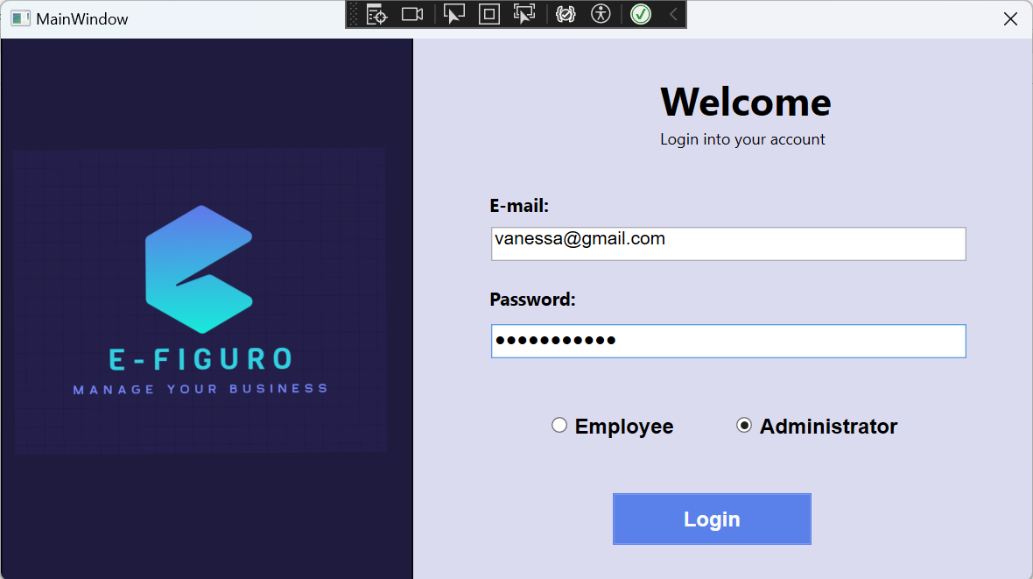

Error message if incorrect email or password is entered or wrong type of account is selected

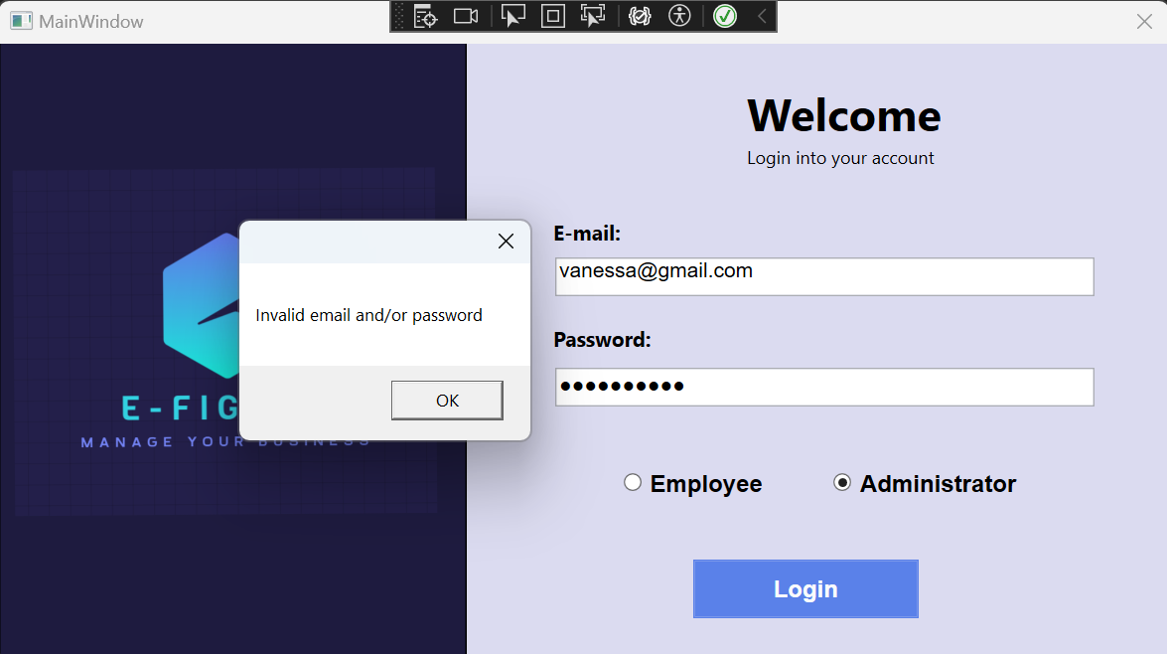

Features page – after successful login, the userID obtained from the login information is saved from this point on until the user logs out. Click “Submit” on any one of the portals to access them.

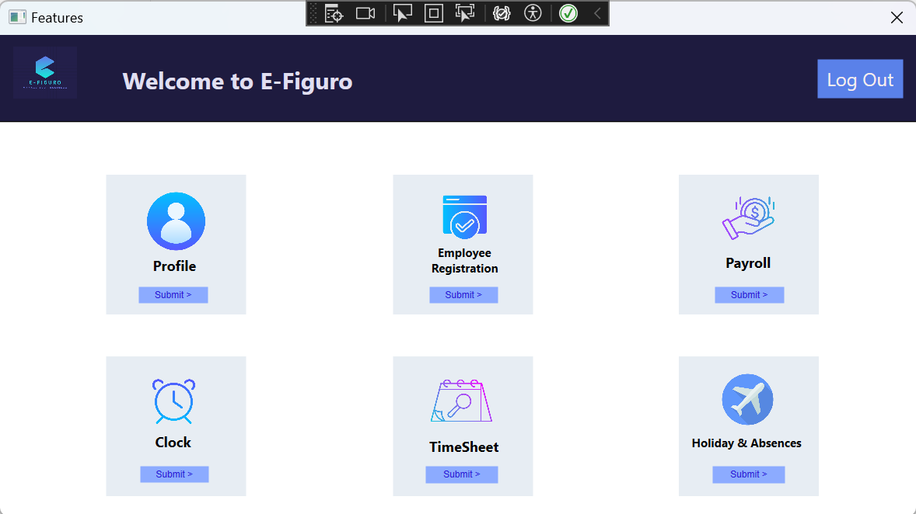

Error message if an Employee user tries to access “Employee Registration” (only administrators can create new users)

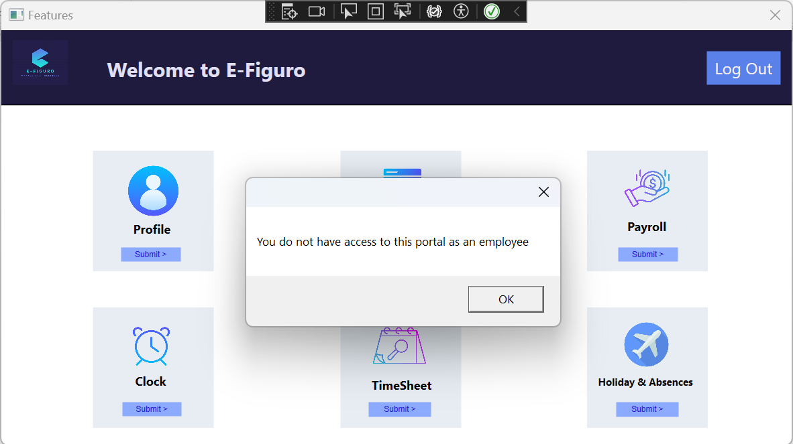

Profile portal – information is automatically pulled from database when window is opened (obtained through the userID that is saved from window to window)

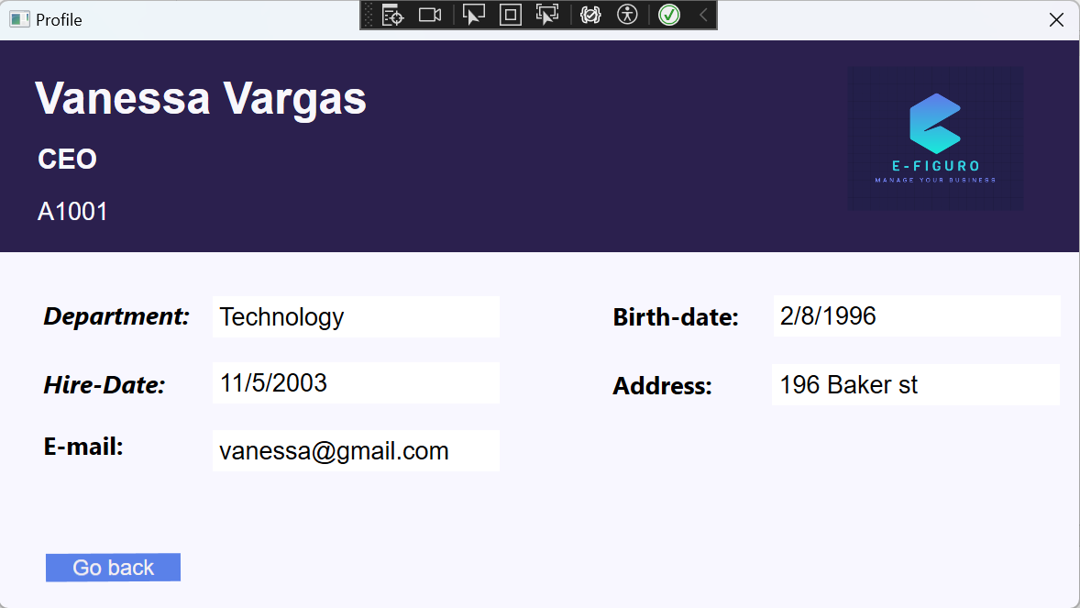

Registration portal

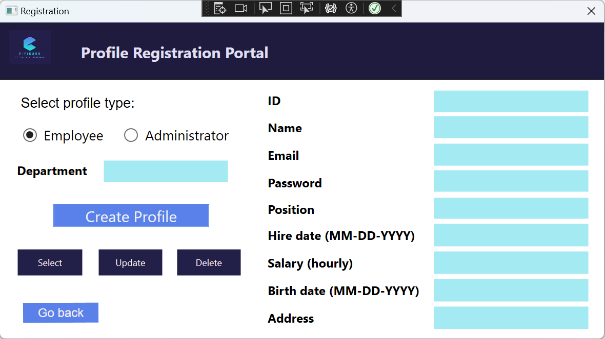

Success message if user clicks “Create Profile” and all fields are correctly filled

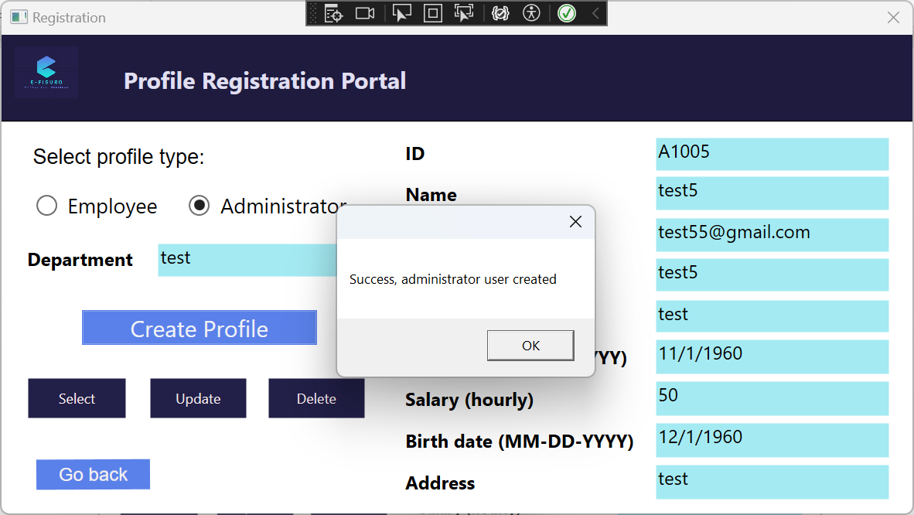

Success message if user clicks “Update” and all fields are correctly filled

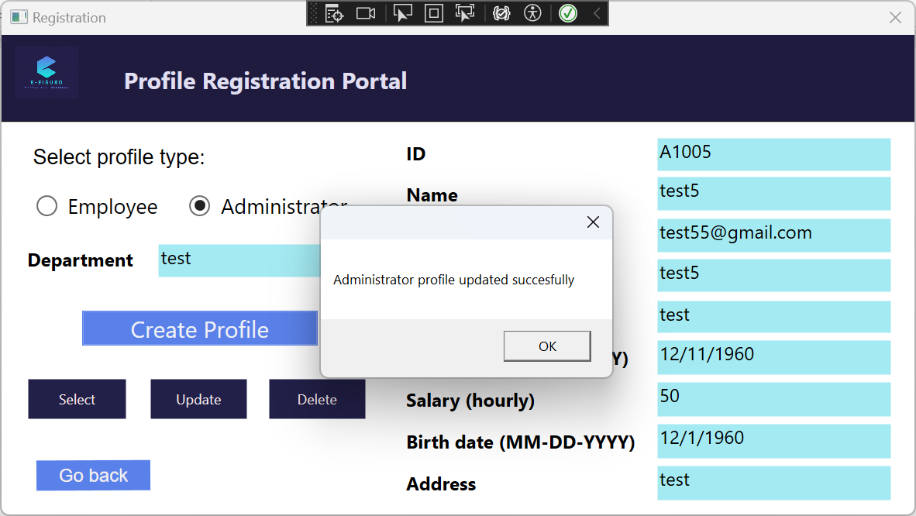

Success message if user clicks “Delete” and the ID matches the ID of an existing user

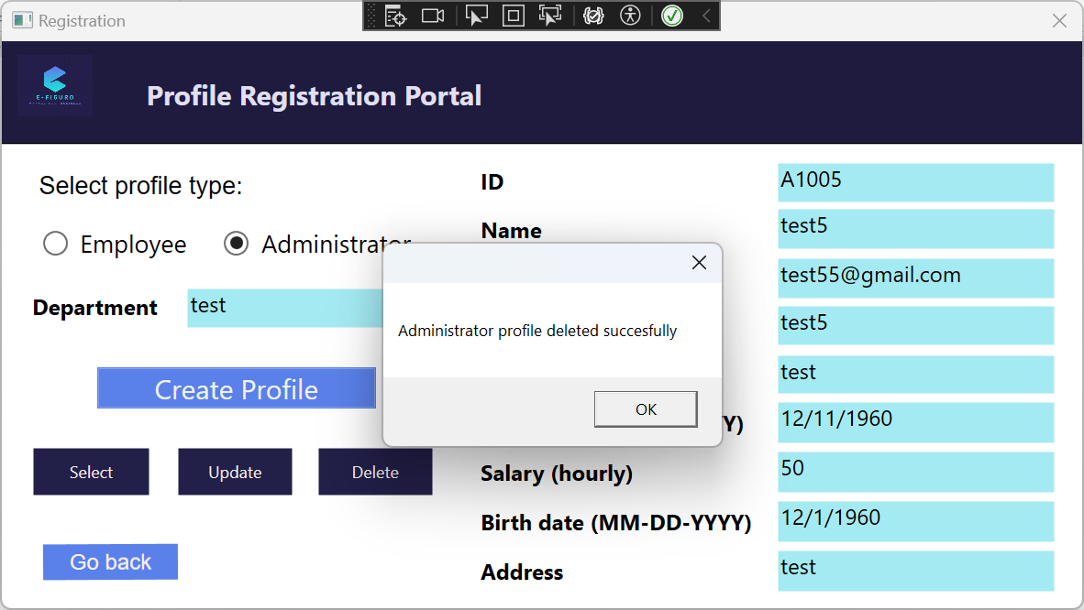

Error message if user tries clicks “Create Profile” without filling all the required fields

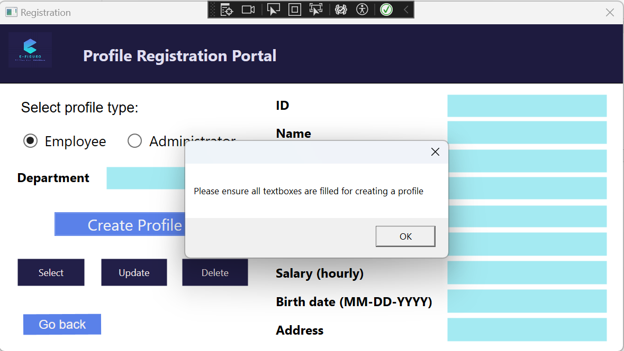

Error message if user does not input an ID when clicking “Select”

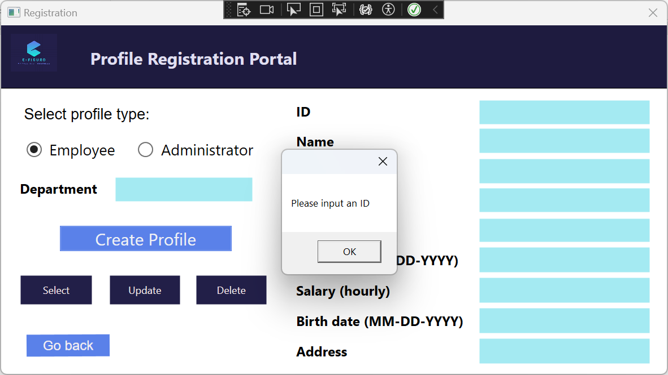

Error message if user tries to “Create Profile” but there is a conflict due to duplicate ID in the database

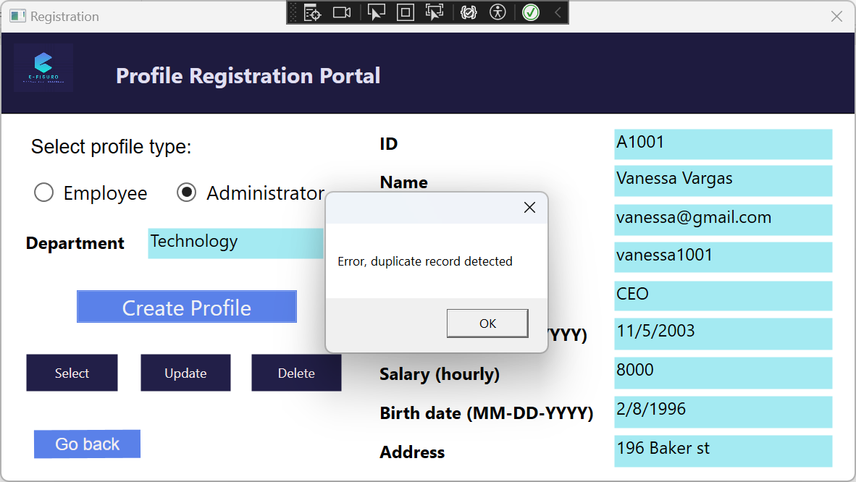

Error message if user enters an ID and clicks “Select” but they did not input the right ID or they put the wrong type of profile type for that ID

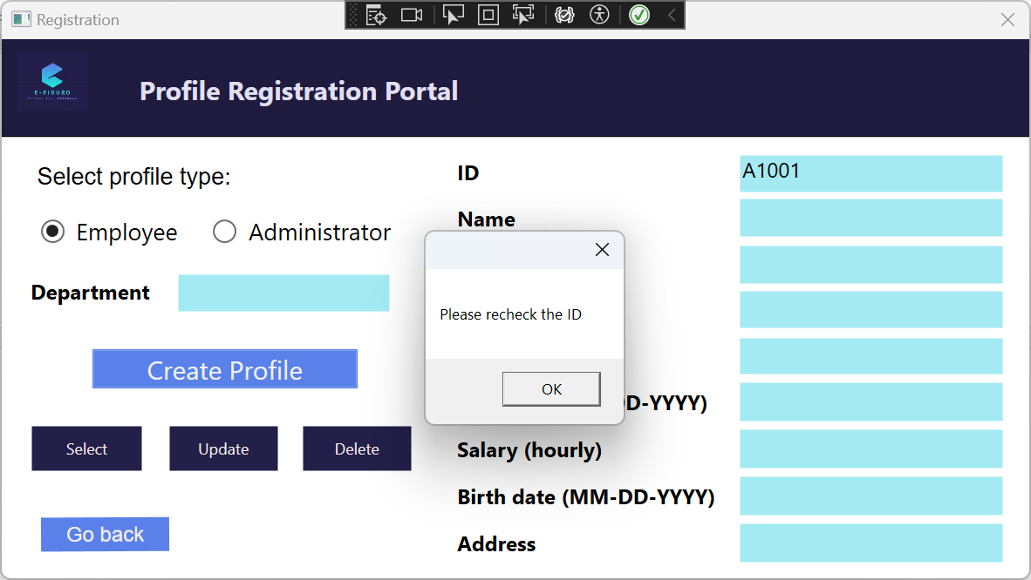

Error message if user tries to “Update” without filling all required textboxes

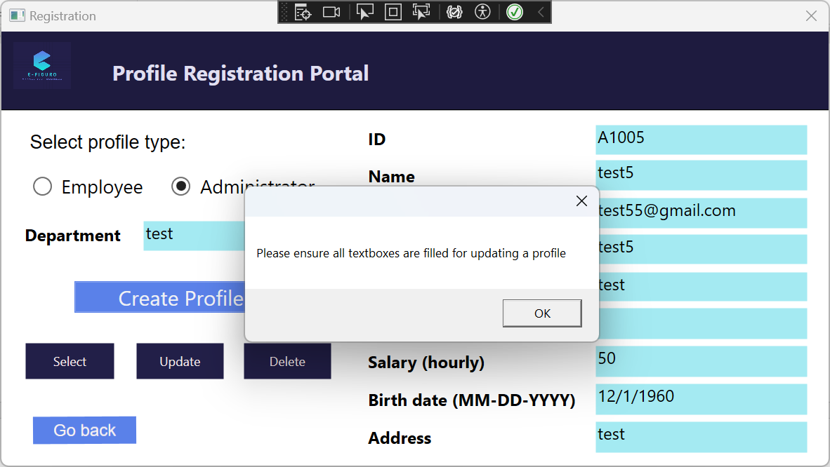

Payroll portal – information automatically pulled from database through userID and relevant calculations done once window is opened

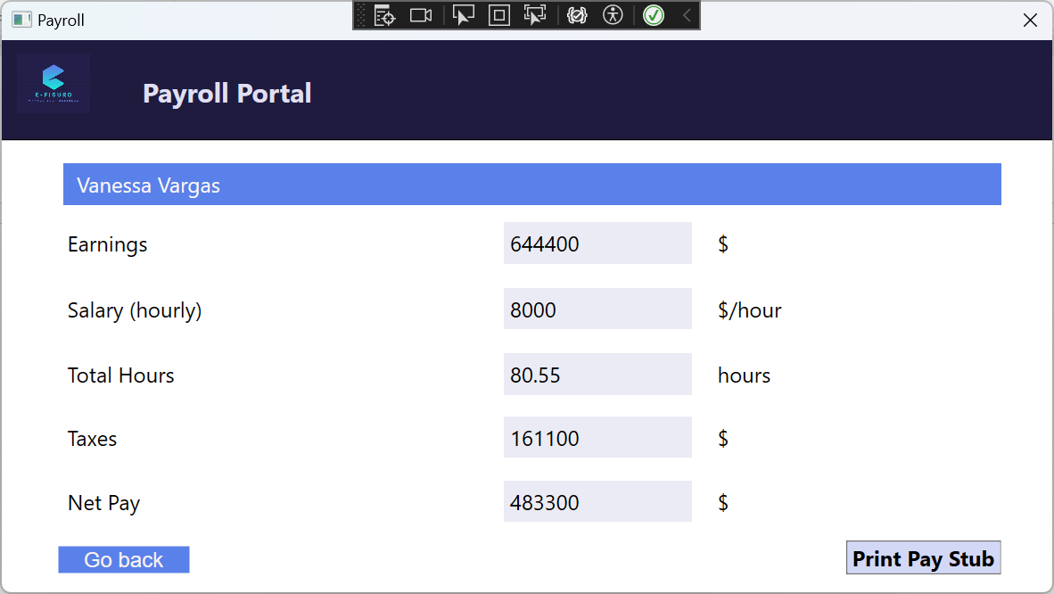

Print window that opens once “Print Pay Stub” is clicked

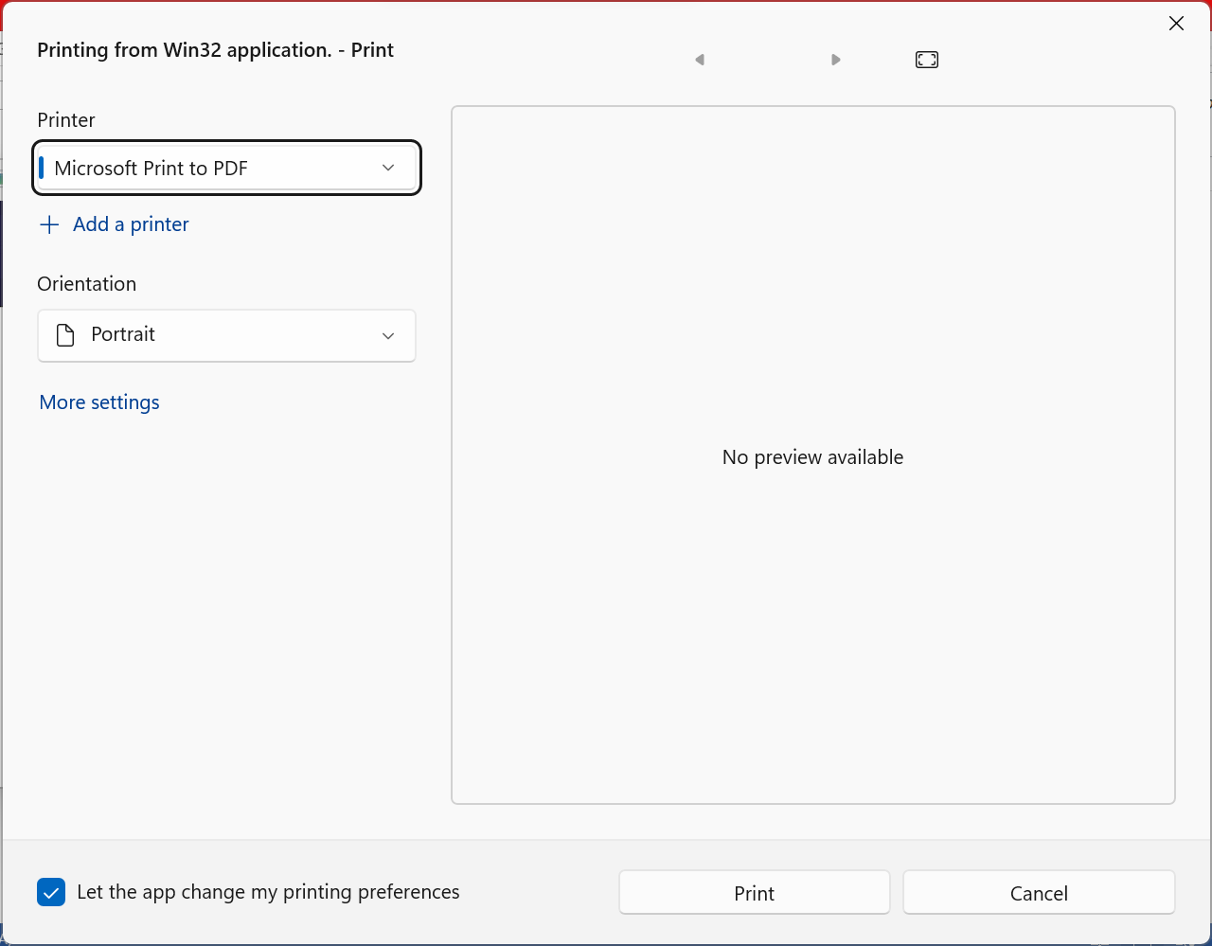

The resulting print page (saved to PDF)

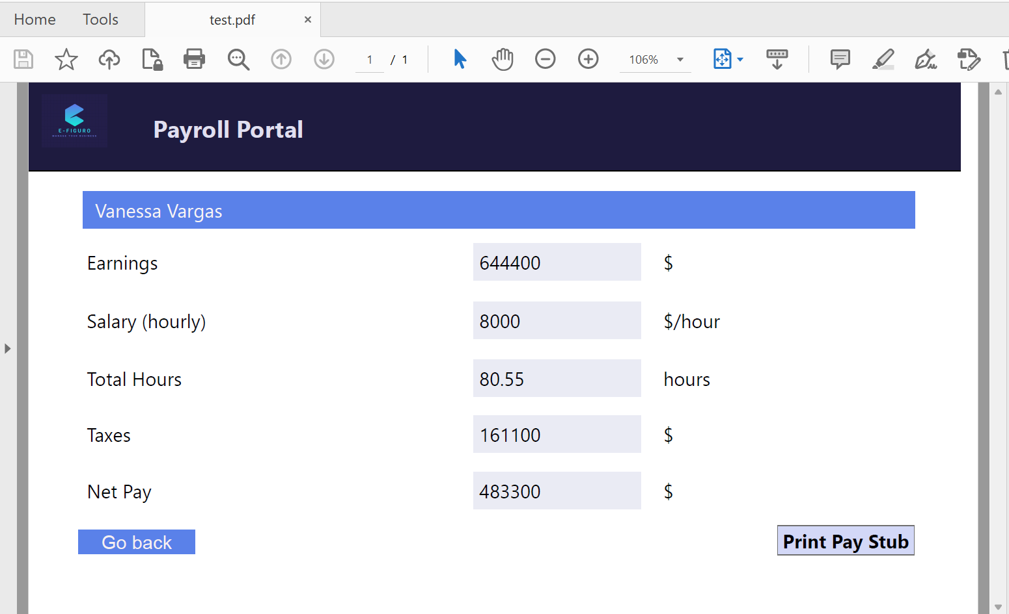

Clock portal (Date and Time automatically initialized based on when the user clicks on this portal)

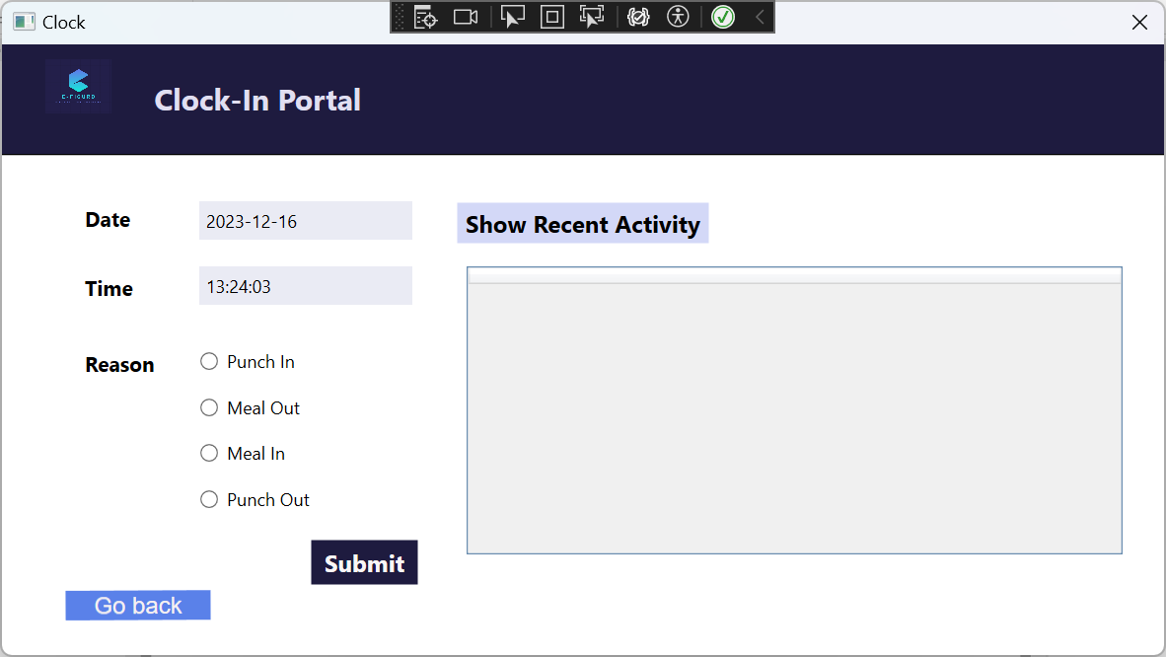

Error message if user tries to click “Submit” without selecting one of the reason circles

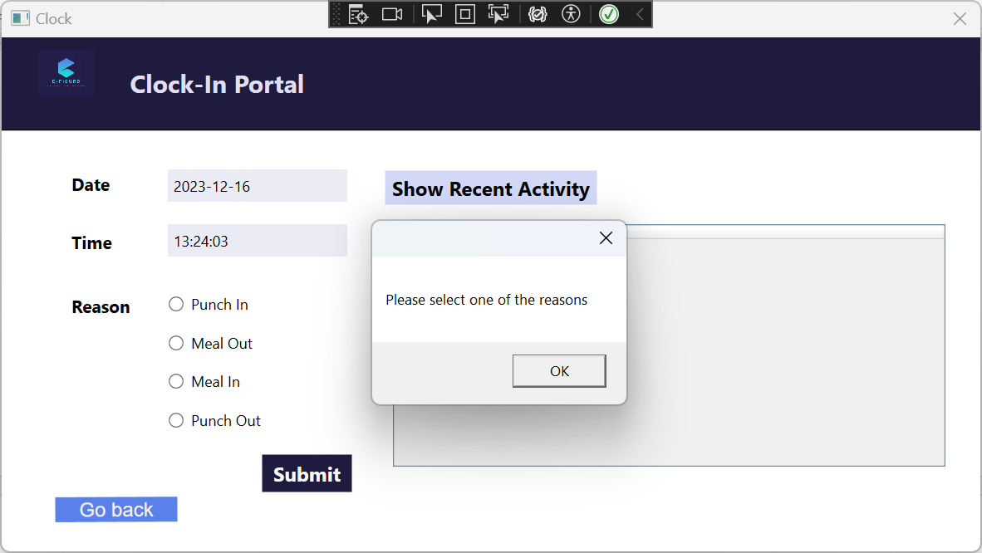

Success message if “Submit” is clicked while “Punch In” is checked

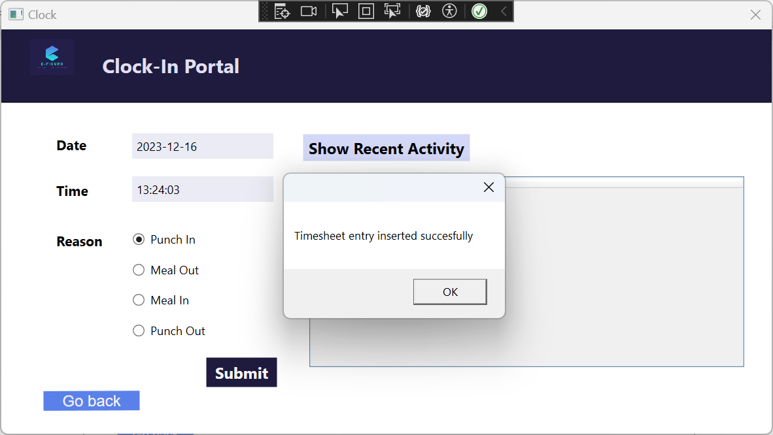

Success message if the “Submit” button is clicked while “Meal Out”, “Meal In”, or “Punch Out” is checked following a successful “Punch In”

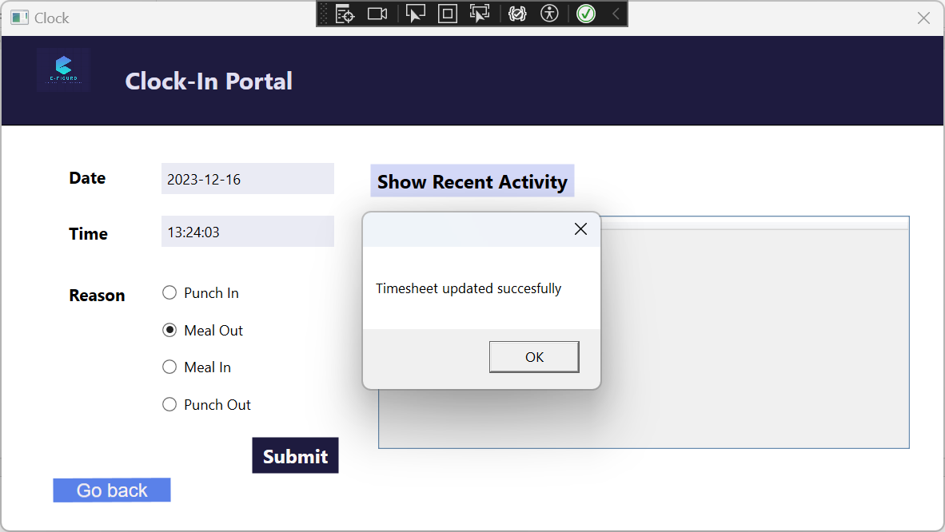

If “Show Recent Activity” is clicked, the calculation for Hours column is done once “Punch Out” + “Submit” is clicked

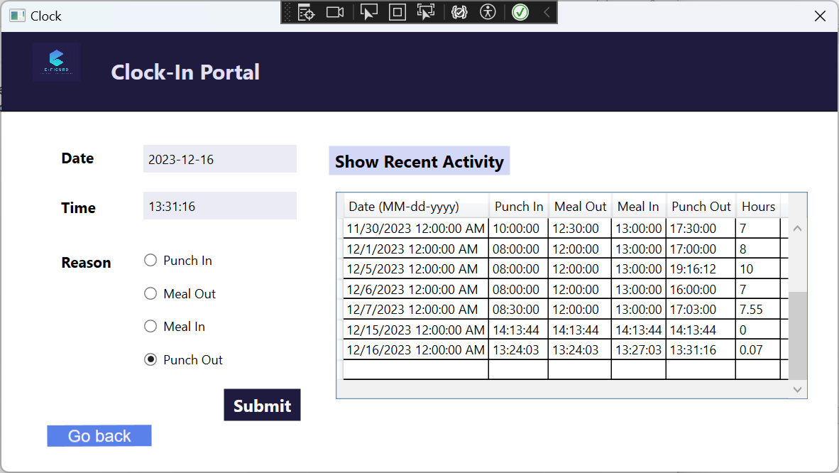

TimeSheet portal

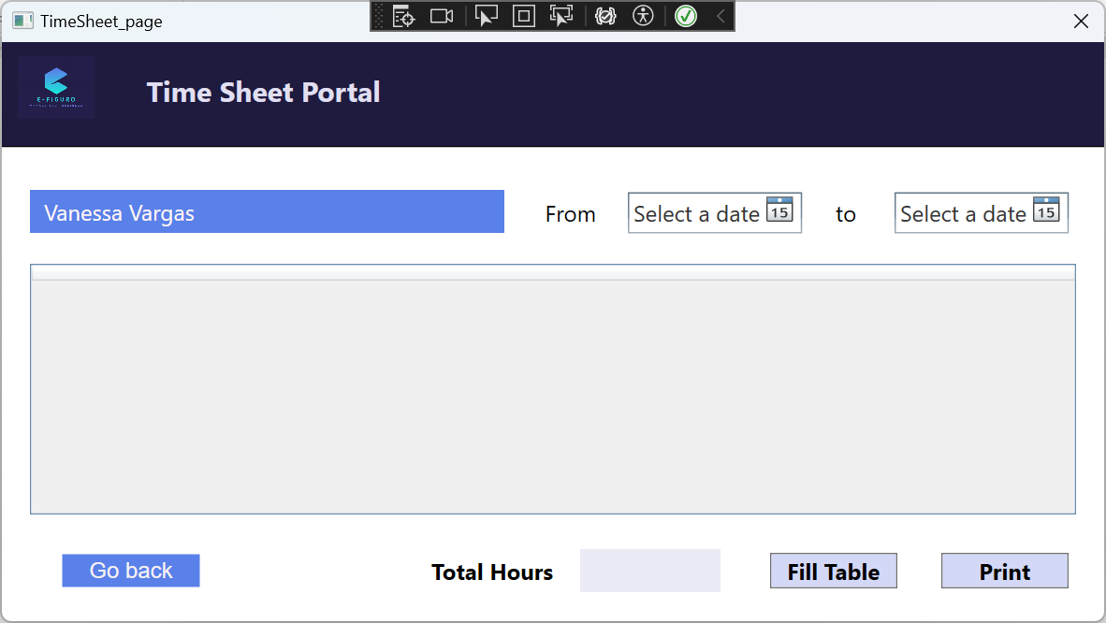

Datatable fills with entries from “DatePicker” to “DatePicker” with calculations being done and also inputting the total hours

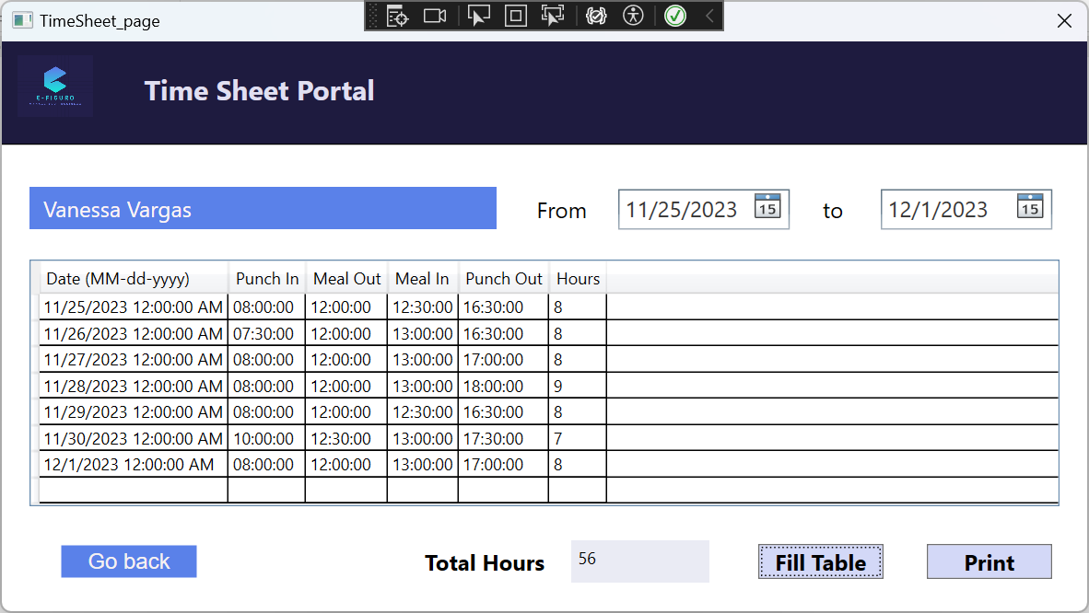

Error message if “Fill Table” button is clicked without selecting dates

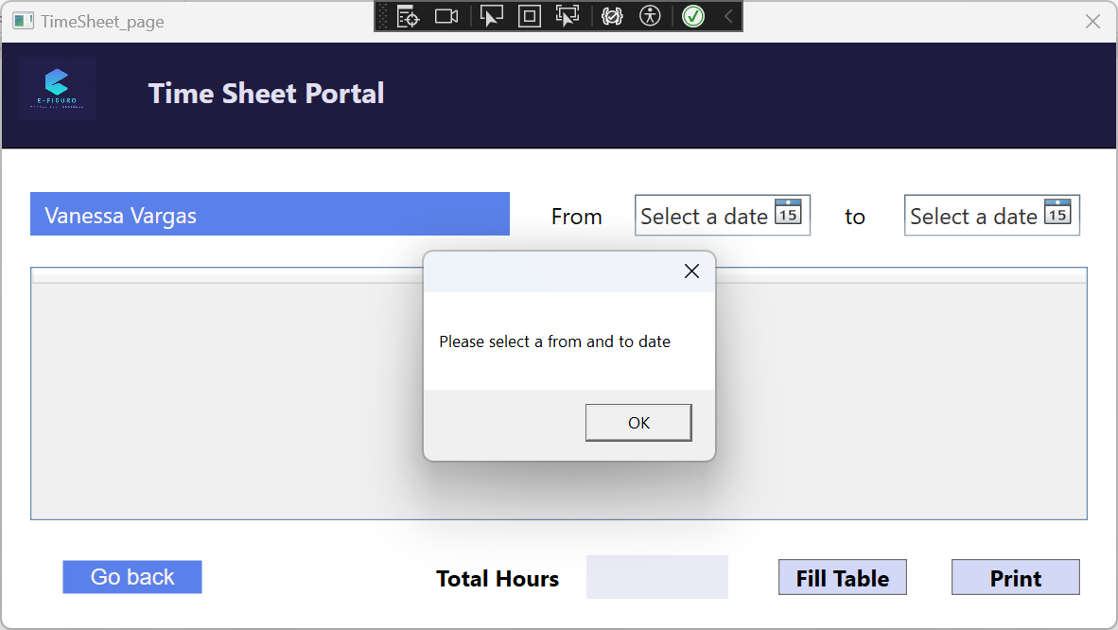

Holiday/Sickday portal

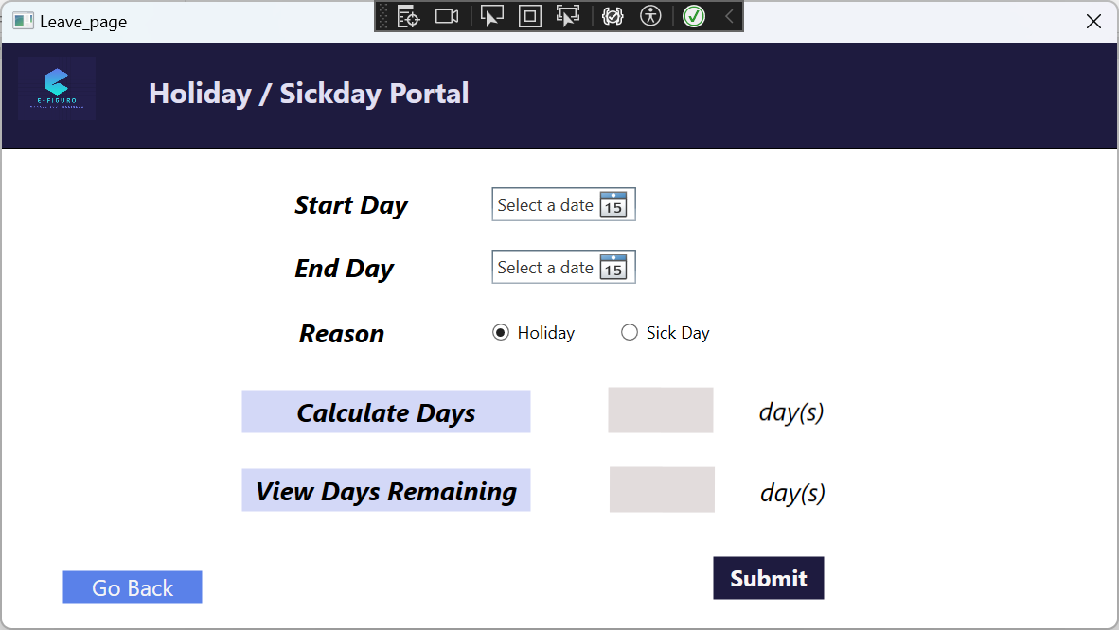

If “View Days Remaining” button is clicked, will perform a calculation to see how many “holiday” or “sick day” days (depending on which circled is selected) are remaining for the user

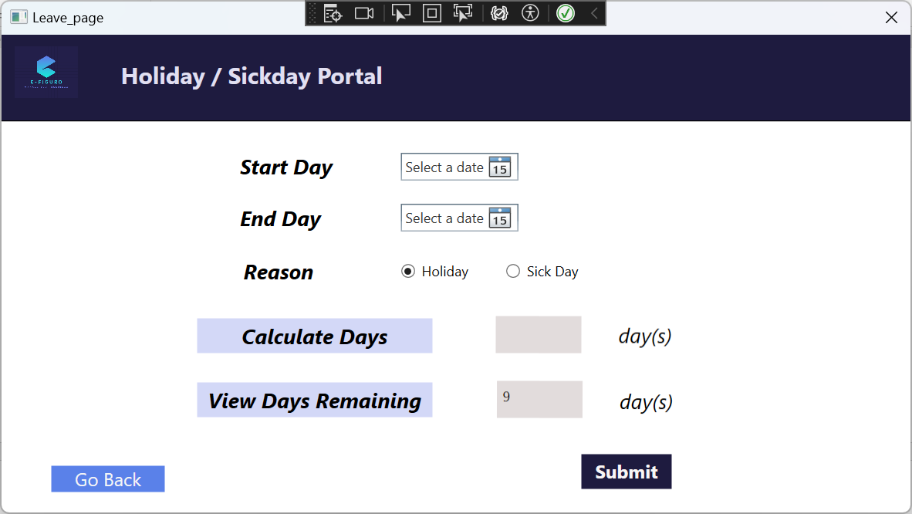

If “Calculate Days” button is clicked, performs calculation based on date of “Start Day” and “End Day” selected

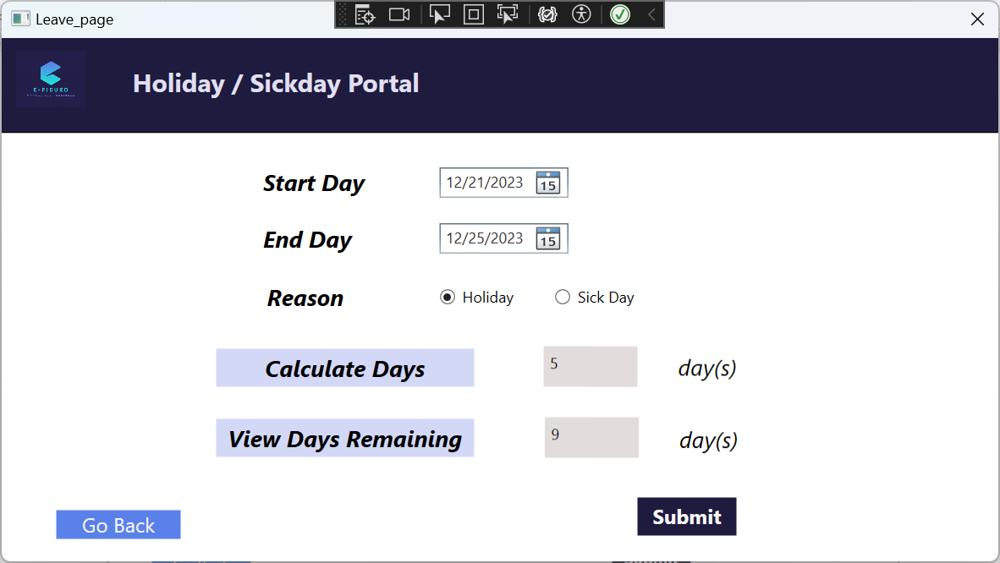

Success message if “Submit” is clicked and everything is okay

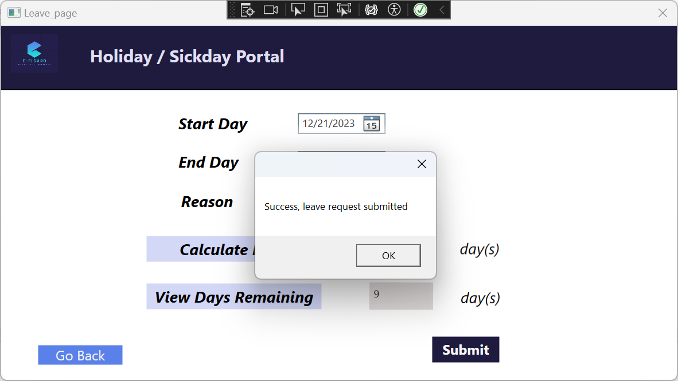

Error message if user tries to submit 2 leave requests that have the same end date

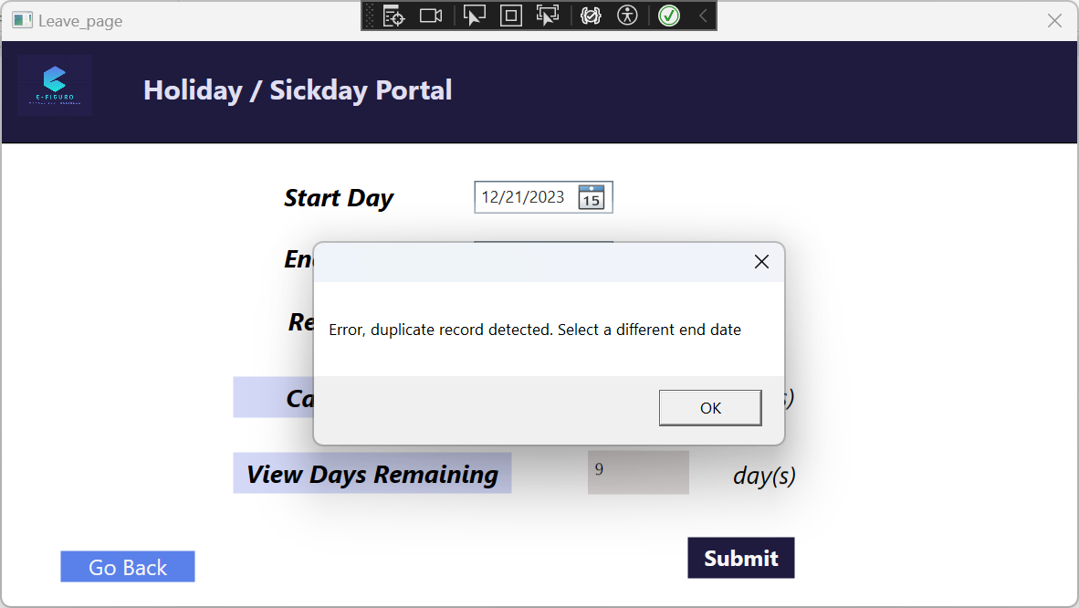

Error message if user tries to click “Calculate Days” when selecting a “Start Day” that is later than “End Day”  
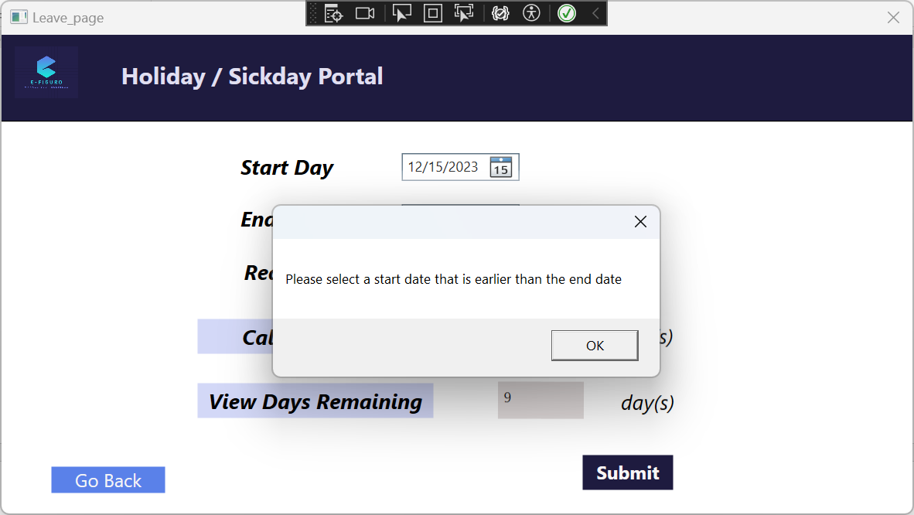

Error message if user tries to click “Submit” when selecting a “Start Day” that is later than “End Day”  
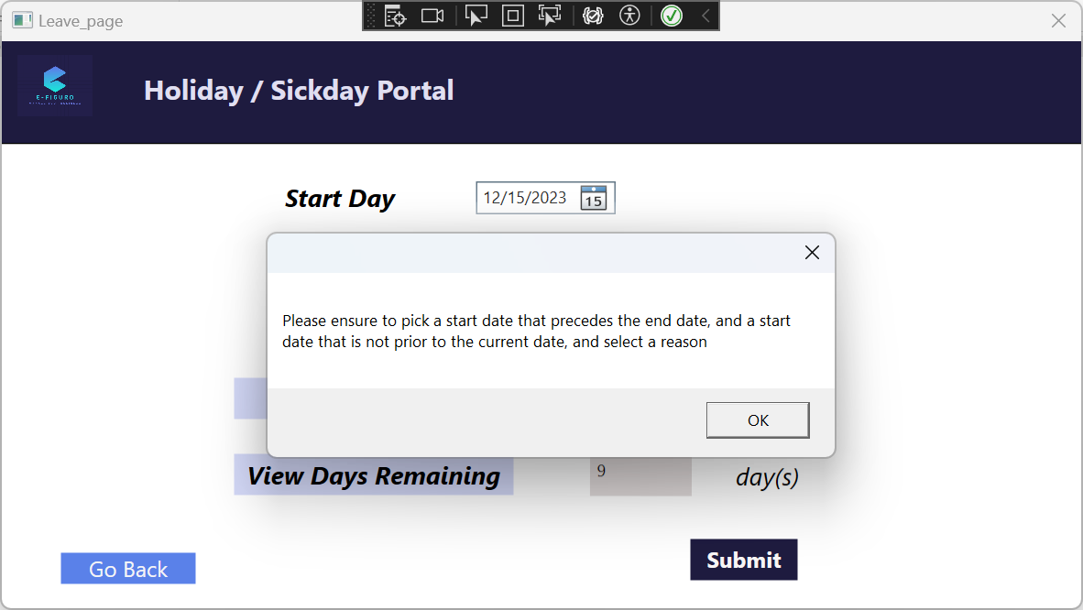

**End screenshots**

3. **Project setup**

This project was developed using Visual Studio 2022 for the coding logic as well as the front-end interface the user interacts with in conjunction with SQL Server Management Studio 19 to provide the database for the user’s information. For the database, a server project (E-Figuro_API) is included to provide complete RestAPI integration for all functionalities of management system. In order to test the project, a NUnit testing project is also included (E-Figuro_NUnitTest). In the current version of E-Figuro, for users to access the functionalities they should have access to and run the program project (E-Figuro_WPF).

4. **Work Progress in Future**

While the current version of the E-Figuro employee management system is relatively complete in terms of implementing the functionalities listed above, there are many improvements that can be done to help improve the scope of this program. Originally there were plans to include an employee performance portal, a portal detailing the user’s benefits (e.g. health/dental insurance), a page to display the hierarchy trees of the company as well as a page to help list career opportunities in the company itself. However these portals were not able to be implemented yet due to time constraints. Integration of artificial intelligence to help keep track of data as well as to recommend career opportunities based on the user’s strengths and weaknesses would also be compelling features to integrate into the program.

In addition, a few bug fixes have already been identified and will be addressed for the next version:

* Add exception handling for TimeSheet portal: if a start date that is later than end date is selected and “Fill Table” is clicked
* Add print preview when clicking on “Print page” (Payroll and TimeSheet portals)
* Add exception handling for Registration portal: if clicking on “Delete” and the userID doesn't exist already
* Add exception handling for Leave portal: if the user does not select a start or end date and then clicks on “Submit”